Paper title
Author #1
Author #1 affiliation, City, Country
Author #2
Author #2 affiliation, City, Country

Abstract
Authors of papers to proceedings have to type these in a standardized form in order to ensure uniform style throughout the volume. The reference format for submitting papers is PDF in A4 size. The publisher will reduce the PDF file to 82% and print it in black only.
For the convenience of the authors, template files are provided. This is the MS Word template (A4 size paper). It is suggested to start by directly editing or inserting text in this file. The expected paper length is between 6 and 8 pages.
Do not number the pages.

Introduction
This is the introduction...

ABOUT CITATIONS
In the text, use authors’ last names with the year of publication in parentheses as done by Paidoussis (1998). If there are more than two authors, use “et al”, e.g. Ziada et al (2003). You can also use the form (author, year) as in (Ziada et al, 2003). If there are multiple citations, use (;) as in (Paidoussis, 1998; Ziada et al 2003).
At the end of the paper, list all references in alphabetical order underneath the heading REFERENCES.

About section titles

Subsection title

Subsubsection title

About equations, figures and
tables

Figures
Figure 1 is a photograph of the Plateau de Saclay, EDF Lab in foreground and École polytechnique in background.

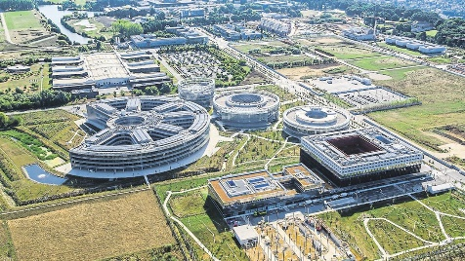
Figure 1. The magnificent Plateau de Saclay.

Tables
Tables 1 and 2 give values of parameters for FIV2022 papers.

 | cm | inches
Text width | 17 | 6.68
Left margin | 2 | 0.786
Right margin | 2 | 0.786
Top margin | 2.7 | 1.06
Bottom margin | 3 | 1.179
Table 1. A4 size paper settings

Normal text | 11pt normal
Title | 12pt bold capitals
Section title | 11pt bold capitals
Subsection title | 11pt bold
Subsubsection title | 11pt italic
Figure or table caption | 11pt italic
Table 2. Fonts.

Equations
A typical equation should have the form of equation $\left(1\right)$,
$$\begin{aligned}mh_{b}^{2}\frac{d^{2}θ}{dT^{2}}+C\frac{dθ}{dT}+K_{T}θ=0. \#\left( SEQ Équation \backslash * ARABIC 1\right)\end{aligned}$$

For automatic equation numbering in Word, see e.g. https://superuser.com/a/1121557.

Conclusion
For any questions: fiv2020@sciencesconf.org

References
Paidoussis, Michael P., 1998, Fluid-structure interactions: slender structures and axial flow, Academic Press.
Ziada, S. et al, 2003, Flow excited resonance of a confined shallow cavity in low Mach number flow and its control. Journal of Fluids and Structures 18: 79-92.

